**Goal**

The goal of this work is to gain an introduction to thermography (terminal imaging) of plants.

**Setup**

A FLIR E5 thermal camera was used to image 18 soybean plants in a greenhouse. The plants were then moved the plants were moved to an air conditioned head-house (~72F) and imaged three more times, ten minutes apart.

**Analysis assumptions**

1) There are 18 plants with the first nine (treatment 1) differing from second nine (treatment 2) by presence or absence of overhead lighting. 2) The 18 plants were measured in the same order during each of four imaging periods.

**Expectation**

The plants will appear warmest while in the greenhouse and cool down while in the head-house. There may a difference the two treatments, but not likely given the treatments are similar. Little difference is expected between the plants within a treatment during each imaging time. The rate of cooling down in the head-house may suggest the maximum time the plants might be in the head-house before a difference in groups is no longer measurable.

**Background**

The FLIR E5 camera is a handheld thermography camera for inspections of machine and buildings. The camera contains both a digital RGB camera and a thermal camera and creates superimposed images. The resolution of the thermal camera is 120x90 with an accuracy of “±2°C (±3.6°F) or ±2% of reading, for ambient temperature 10°C to 35°C (+50°F to 95°F) and object temperature above +0°C (+32°F)[1].” Instead of a characteristic of the sensor, the accuracy appears to be intentionally degraded by the manufacturer[2].

**Procedure**

Each image from the camera contains a color image, a thermal image, and metadata. For each image, the terminal image was separated and used to create a mask[3]. The thermal image was then converted to a 120x90 matrix of temperature readings and the mask used to isolate the plant temperature readings. Clearly defined leaves were included in the mask while stems and small or distant leaves were generally not. After masking, there are of roughly 1000 temperature measurements for each plant.

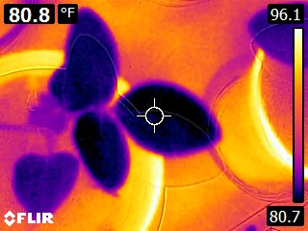

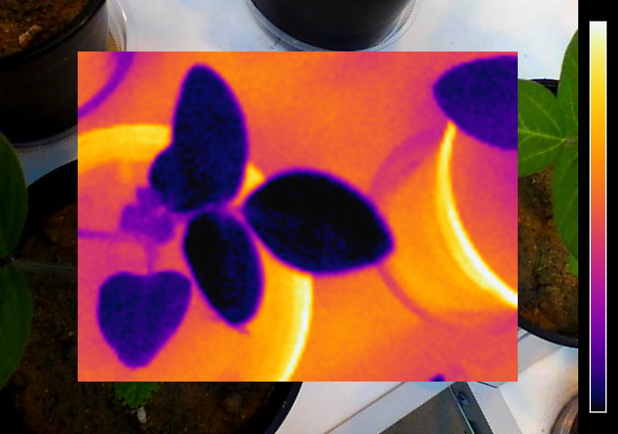

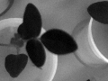

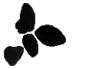

**Analysis**

The time points are called A, B, C, and D, and the suffixes 1 and 2 designate the two treatments. The left graph shows each group and treatment, while the right graph combines the treatments and shows only the groups. In both graphs, the median temperatures are plotted. Comparing treatments, the median temperature of the second treatment plants is higher and more slowly cools in the head house then the first treatment. While groups B-D (measured in the head-house) show a cooling trend, group A (measured in the greenhouse) are not the highest temperatures.

Assuming the plants were imaged in the same order at each time point, it would be expected that there would be some relative grouping and trends. However, no trends are seen beyond those seen in the bar charts.

Additional information is available in the temperature distributions of each measurement. The histogram of leaf temperature is a more distinct signature than the median temperature value.

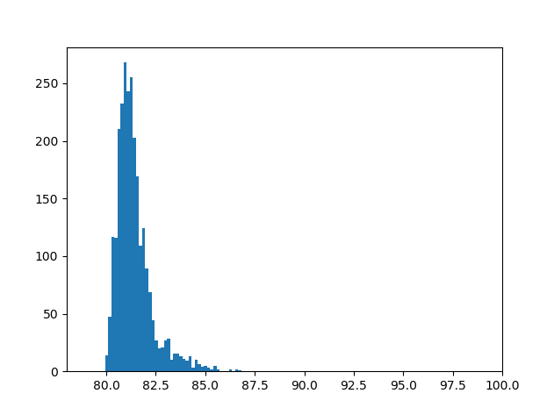 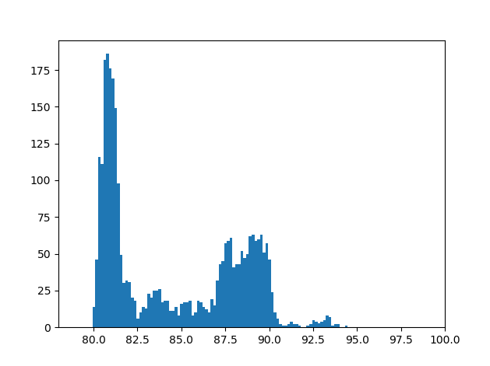 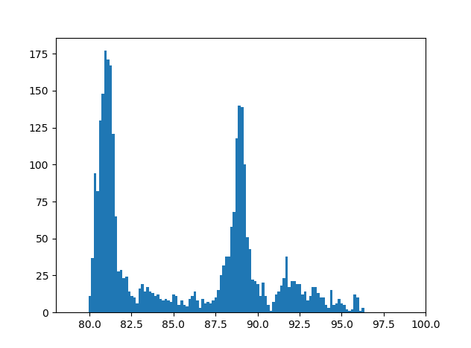

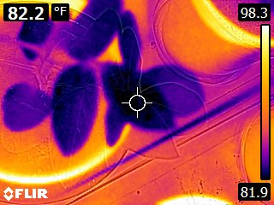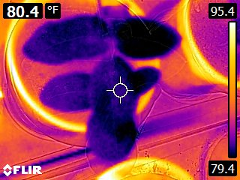

Histograms of masked thermal images with 128 bins were created between the minimum and maximum temperatures across all groups and treatments. All pairs (18 plants x 4 time points) of histograms were compared using the earth mover distance (EMD) metric to generate a 72x72 matrix summarizing distance between all pairs of histograms. Beyond one bad measurement, no clear patterns emerge.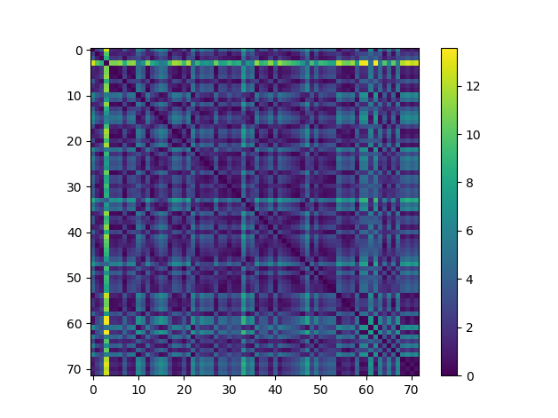

**Conclusion**

The absence of clear distinction between treatments in the described experiment should not reflect poorly on the technology. A drought experiment would be better, where leaf transpiration and thus temperature is expected to differ. The sensitivity of the experiment is also limited by the camera accuracy. It may be possible to reduce the camera’s noise through software modification. Alternatively, with a rig to hold the camera rigidly while multiple images are collected, the images could be stacked to improve signal-to-noise (SNR).

1. from the camera specifications
2. <https://www.eevblog.com/forum/thermal-imaging/flir-e4-thermal-imaging-camera-teardown/msg342315/#msg342315>
3. The RGB image is poorly registered with the thermal image and could not be used for segmentation.